Project 2 Portfolio Title:
AI-Augmented Predictive Maintenance: From IoT Factory Sensor Logs to Automated Engineering Incident Reports

The Goal
Build an automated operations pipeline that turns raw factory machine logs into:
An overall Equipment Effectiveness (OEE) status matrix.
Machine health triage alerts.
Automated root-cause technical maintenance instructions.
An interactive Looker Studio Factory Floor Dashboard.

The Workflow Blueprint
Plaintext
[Raw IoT Logs] ──> [Deterministic Math Engine] ──> [Gemini JSON Contract] ──> [Interactive Maintenance Triage]

The Beginner Use Case: Machine Sensor Logs
You will generate a dataset simulating factory floor machinery.
Columns: Timestamp, Machine ID, Machine Type (e.g., CNC Router, Injection Molder), Vibration Metric (mm/s), Internal Temperature (°C), Operating Hours, Total Parts Produced, Defective Parts Count.

Hidden Business Anomalies to Inject:
The Imminent Bearing Failure: A machine where Vibration spikes steadily over 3 days while Internal Temperature hits over 85°C (a classic mechanical friction warning).
The Quality Drift: A machine where the number of Defective Parts Count suddenly quadruples, but temperature stays completely normal (indicates a tool calibration alignment failure, not a motor failure).
The Overworked Asset: A machine passing 1,000 continuous operating hours without a flagged maintenance log, causing total efficiency output to steadily plummet.

The 5-Day Build Plan
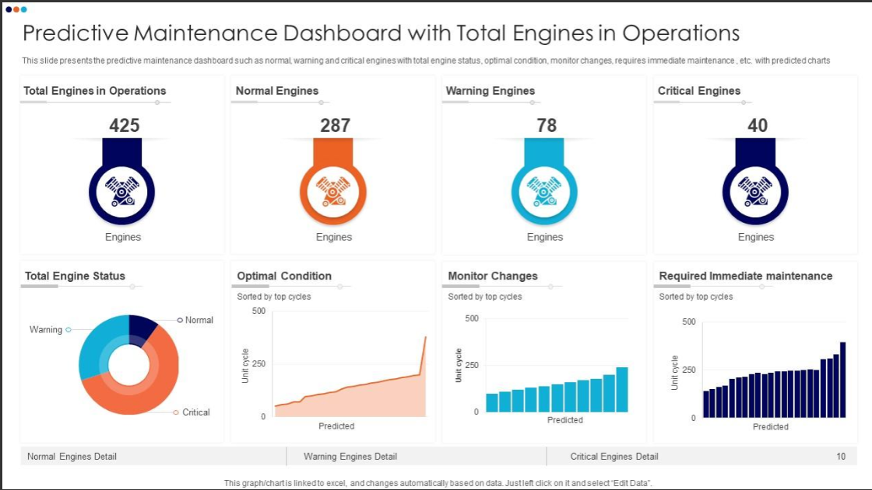

Day 1: Data Creation & Failure Architecture Setup
Task: Run a Python simulation script to build a 200-row telemetry log.
Output: Clean raw IoT comma-separated file imported into Google Sheets.

Day 2: The Deterministic Health Layer (OEE Formulas)
Task: Calculate Overall Equipment Effectiveness (OEE) using strict formulas:
$\text{Availability} = \frac{\text{Actual Operating Time}}{\text{Planned Production Time}}$
$\text{Performance} = \frac{\text{Total Parts Produced}}{\text{Target Capacity}}$
$\text{Quality} = \frac{\text{Good Parts Produced}}{\text{Total Parts Produced}}$
$\text{OEE} = \text{Availability} \times \text{Performance} \times \text{Quality}$

Day 3: AI Incident Triage via Google AI Studio
Task: Build a structured JSON system prompt contract that forces Gemini to act as a Chief Maintenance Engineer.
Output: A structured JSON incident report detailing the exact machine ID failing, the root cause (mechanical vs. calibration), and exact step-by-step mechanical fix protocols.

Day 4: Looker Studio Factory Control Dashboard
Task: Map your data sheet into a live tracking grid using conditional color-coded conditional alert mapping (Red/Orange/Green machine risk statuses).

Day 5: Portfolio Documentation & Git Assembly
Task: Draft the "Responsible AI" documentation explaining how automating mechanical diagnostics saves engineering hours while keeping human operators as the final verification layer.

